Education Standards Board

SharePoint – SQL Database

Management Recommendation

20/07/2023

# Overview

* It was observed a SharePoint Health Analyser error being shown in Central Administration

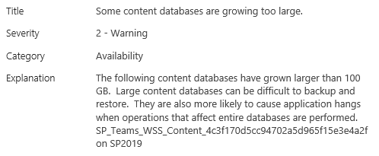

# Observations

* A single content database is being used for the Teams web application, with all site collections being stored within it

|  |  |  |
| --- | --- | --- |
| Site Collection in Teams Database | Size | Comment |
| http://eecsrsb2019-teams.sa.gov.au/ | 485,645 MB | Primary Site Collection |
| http://eecsrsb2019-teams.sa.gov.au/sites/DevSC | 664 MB | Old Development Site |
| http://eecsrsb2019-teams.sa.gov.au/sites/Test | 1 MB | Not Used Test Site |

* The database related to the warning message is 500GB+ in size. Microsoft recommends database are kept to below 100GB in size, this is primarily for speed of backup and restoration if required, though there are also performance impacts if database size grows larger than 200GB.
* SQL Database Actual Space used is reported as below for the Teams Database

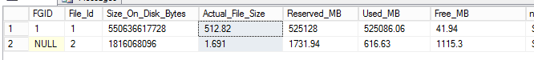

* SQL Database Maintenance Plans are not in place for EECSBSQL02
  + They are in place for EECSBSQL01. Which contains SharePoint Database not being used for current Production SharePoint Farm

# Recommendations

1. **Configure SQL Maintenance Plans for SQL02**

* Maintenace Plans are scheduled tasks on the SQL Server to performs regular activities to ensure databases are maintained and backed up
  + These plans are configured and schedule to run regularly
* Maintenance Plans below are shown already configured on EECSBSQL01

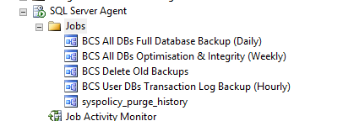

* SCREENSHOT: Maintenance Plans shown for EECSBSQL02

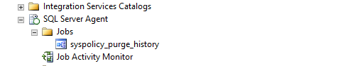

* It is recommended to copy the setup and configuration of the following Maintenace plans from SQL01 to SQL02
  + BCS All DBs Full Database Backup (Daily)
  + BCS All DBs Optimisation & Integrity (Weekly)
  + BCS User DBs Transaction Log Backup (Hourly)

1. **Restructure SharePoint Sites into separate Site Collections and Content Databases**

* Current SharePoint Architecture is structure in a hierarchical format – where there is only 1 Site Collection with all sites nested underneath. This format limits the ability to host sites in multiple databases as you can only split Site Collections between databases.
* It is recommended to split the ESB SharePoint Team content into multiple content databases. This is not a small task, a small project to migrate the subsites into their own site collections would be required. This would involve planning, testing, and outage management. It's estimated this would take an effort of 10 days.
* Show below is the Storage Metrics from the current Teams Site Collection, with the subsites showing along with their storage size being used. 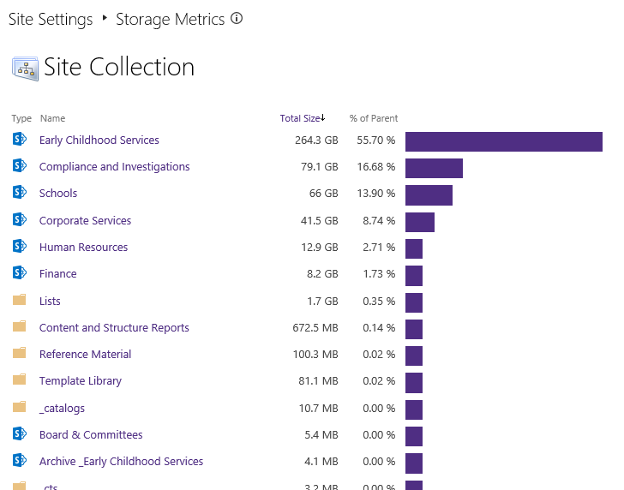

1. **Clean-up / Archive database on EECSBSQL01**

* EECSBSQL01 contains databases used for the old, decommissioned SharePoint Server 2013 instance. These databases would have been copied over to the new database server (SQL02) at the time of upgrade.
* EECSBSQL01 also contains TIMEWISE database which may still be in use
  + ESB_TIMEWISE_PROD
  + ESB_TIMEWISE_TEST
* It is recommended all these databases are deleted. They are consuming disk space on this server along with resources, and the service they supported has been decommissioned, with any required Data migrated to the new platform.

|  |  |
| --- | --- |
| **Name** | **Size (MB)** |
| ESB_TIMEWISE_PROD | 700 |
| ESB_TIMEWISE_TEST | 250 |
| NW2013DB | 236.5 |
| SBMessageContainer01 | 2687.625 |
| Search_Service_Application_1_AnalyticsReportingStoreDB | 62.5 |
| Search_Service_Application_1_CrawlStoreDB | 62.5 |
| Search_Service_Application_1_DB | 153.4375 |
| Search_Service_Application_1_LinksStoreDB | 62.5 |
| Search_Service_RecordPoint_AnalyticsReportingStoreDB | 62.5 |
| Search_Service_RecordPoint_CrawlStoreDB | 70.25 |
| Search_Service_RecordPoint_DB | 153.4375 |
| Search_Service_RecordPoint_LinksStoreDB | 62.5 |
| SharePoint_Config_New | 62.5 |
| SP_App_Management | 62.5 |
| SP_CentralAdmin | 1180.125 |
| SP_Config | 2462.5 |
| SP_Content_EECSRSB-SP_01 | 15177.4375 |
| SP_Content_Mysites_01 | 1712.5 |
| SP_Content_Teams_01 | 529212.5 |
| SP_Content_TEST_01 | 322.1875 |
| SP_HealthReview | 62.5 |
| SP_ProfileDB_Profile | 112.5 |
| SP_ProfileDB_Social | 62.5 |
| SP_ProfileDB_Sync | 169.6875 |
| SP_SA__Search | 218.4375 |
| SP_SA__Search_AnalyticsReportingStore | 62.5 |
| SP_SA__Search_CrawlStore | 1590.9375 |
| SP_SA__Search_LinksStore | 477.4375 |
| SP_SA_BDC | 62.5 |
| SP_SA_Managed_Metadata_Service | 112.5 |
| SP_SA_RP_Search | 153.4375 |
| SP_SA_RP_Search_AnalyticsReportingStore | 272.625 |
| SP_SA_RP_Search_CrawlStore | 2766.8125 |
| SP_SA_RP_Search_LinksStore | 888.6875 |
| SP_SA_Secure_Store_Service | 62.5 |
| SP_SA_State_Service | 112.5 |
| SP_Workflow_InstanceManagementDB | 74.5625 |
| SP_Workflow_ManagementDB | 62.5 |
| SP_Workflow_SbGatewayDatabase | 62.5 |
| SP_Workflow_SbManagementDB | 62.5 |
| SP_WSS_Logging | 3551.8125 |
| WFResourceManagementDB | 62.5 |
| WSS_Content_RecordPoint | 15772.1875 |
| WSS_RPContent_20161025120319 | 179283.125 |
| WSS_RPContent_20161025120610 | 32151 |